**Spam Email Classification using NLP and**

**Machine Learning**

A Project Report

submitted in partial fulfillment of the requirements

of

AICTE Internship on AI: Transformative Learning

with

TechSaksham – A joint CSR initiative of Microsoft & SAP

by

**Muthukumaran E**

**muthukumarane2002@gmail.com**

Under the Guidance of

**Abdul Aziz Mohammad**

**Master Trainer,Edunet Foundation**

**ACKNOWLEDGEMENT**

I would like to take this opportunity to express my sincere appreciation to all those who have supported and contributed to the completion of this thesis, both directly and indirectly.

First and foremost, I extend my deepest gratitude to my distinguished supervisors, Abdul Aziz Mohammad and Pavan Sumohana, whose exceptional mentorship has been a cornerstone of this thesis. Their insightful guidance, thoughtful suggestions, and constructive critiques have not only inspired and motivated me but have also shaped the direction and success of this research. The confidence they placed in me has been a constant source of encouragement, and their unwavering support throughout this journey has been invaluable. It has been a true privilege to work with such dedicated and knowledgeable advisors. Beyond academic assistance, the lessons and perspectives they shared have greatly influenced my development as a professional, instilling in me a sense of responsibility and integrity that will continue to guide me throughout my career.

I would also like to express my heartfelt gratitude to the Edunet Foundation, Techsakhsham, and the entire team for providing me with the opportunity to participate in their virtual training internships. This invaluable experience has enhanced my knowledge of Artificial Intelligence and Machine Learning, providing me with practical skills that have significantly enriched my project.

I am deeply grateful to my family and friends for their unwavering love, support, and understanding throughout this journey. To my parents, thank you for your constant encouragement and sacrifices; your belief in me has been a guiding light. To my siblings, your patience, understanding, and cheer have been invaluable, and I’m thankful for your unwavering support. To my friends, your camaraderie, thoughtful discussions, and encouragement have kept me grounded, especially during the most challenging times. Whether through a kind word or a helpful suggestion, your presence has made this journey much easier and more enjoyable.

Finally, I would like to acknowledge all those who have contributed, directly or indirectly, to the successful completion of this project. Your kindness, encouragement, and assistance have been deeply appreciated.

#### **ABSTRACT**

This project focuses on classifying spam emails using Natural Language Processing (NLP) and Machine Learning (ML) techniques, specifically applying Naive Bayes and CountVectorizer. Spam emails remain a significant issue in modern communication, affecting both efficiency and user experience. Effective automation of spam detection is crucial for improving email system functionality.

**Problem Statement:**  
Spam emails are designed to bypass traditional filters, leading to unwanted and potentially harmful messages. Manual identification is time-consuming, highlighting the need for an efficient, automated solution.

**Objectives:**

1. Develop a machine learning model to classify emails as "spam" or "ham" (non-spam).
2. Apply NLP techniques such as text preprocessing, tokenization, and vectorization to transform email content into a suitable format for machine learning.
3. Compare the performance of the Naive Bayes algorithm with other classification models.

**Methodology:**  
The project uses the Enron Email Dataset, which contains labeled spam and ham emails. Text preprocessing steps, including stop word removal, punctuation elimination, and stemming, are performed. The CountVectorizer is employed to convert the email text into a bag-of-words format. The Naive Bayes classifier, a probabilistic model, is used to train the model, and performance is evaluated based on accuracy, precision, recall, and F1-score.

**Key Results:**  
The Naive Bayes model, when combined with CountVectorizer, achieved a classification accuracy of approximately 98%. The model demonstrated strong precision and recall, effectively identifying both spam and ham emails while minimizing false positives.

**Conclusion:**  
The combination of Naive Bayes and CountVectorizer offers an effective and reliable method for classifying emails into spam and ham categories, providing a solid foundation for automated email filtering in real-world applications.

**TABLE OF CONTENT**

**Abstract I**

**Chapter 1.**  **Introduction 1**

1.1 Problem Statement 1

1.2 Motivation 1

1.3 Objectives 2

1.4. Scope of the Project 3

**Chapter 2.**  **Literature Survey 4**

**Chapter 3.**  **Proposed Methodology 8**

**Chapter 4.**  **Implementation and Results 10**

**Chapter 5. Discussion and Conclusion 16**

**References** 19

**LIST OF FIGURES**

|  |  |  |
| --- | --- | --- |
| **Figure No.** | **Figure Caption** | **Page No.** |
|  | **Snapshot of Piechart showing percentage of Spam/Ham emails.** | **10** |
|  | **Snapshot of Word clouds for frequent spam and ham words.** | **11** |
|  | **Snapshot of Model evaluation metrics.** | **13** |
|  | **Snapshot of Example prediction of a spam message.** | **15** |

**CHAPTER 1**

**Introduction**

* 1. **Problem Statement:**

The exponential growth in the volume of emails received daily presents a significant challenge for users. Modern email inboxes often contain a mix of important, irrelevant, and unsolicited messages, which leads to clutter and makes it difficult to efficiently prioritize and manage communications. This issue has become more prominent as email has become a primary communication tool for both personal and professional use. As a result, users are frequently overwhelmed by hundreds, if not thousands, of emails each day.

This deluge of emails not only wastes valuable time but also increases the risk of overlooking crucial messages or falling prey to malicious activities, such as phishing attacks and spam. Without an effective system for sorting and categorizing emails, users are prone to inefficiencies, missed deadlines, and potential security breaches.

The lack of proper email classification can severely hamper productivity and compromise digital security. An automated system capable of classifying emails into meaningful categories—such as spam, promotions, social, or important—could address these issues. Such a solution would streamline email management, enhance user productivity, and significantly reduce the risks associated with phishing and other fraudulent activities. By automating the process of identifying and filtering spam, users could focus on more relevant tasks, thereby improving both efficiency and security.

This project aims to develop a robust email classifier that can accurately categorize incoming emails, contributing to more organized inboxes and safer, more efficient email communication.

* 1. **Motivation:**

This project was chosen due to the growing issue of email overload, which significantly affects both individuals and organizations. As email remains a dominant communication tool in personal, educational, and professional settings, managing large volumes of incoming messages efficiently has become increasingly critical. An automated system to classify and filter emails can enhance productivity by reducing time spent sorting irrelevant content.

The potential applications of this project are vast. For individuals, an email classifier can reduce inbox clutter by filtering out spam, organizing messages into categories (e.g., personal, work-related, promotions), and ensuring important emails are easily accessible. This system saves time and reduces the cognitive load of manual organization.

For businesses, the benefits are more pronounced. A well-designed email classification system can help employees focus on high-priority emails, improving productivity and reducing distractions. By automatically identifying and filtering spam, phishing attempts, or malicious content, the system enhances cybersecurity and protects users from harmful emails.

On a personal level, I have experienced the challenges of email overload firsthand. Managing multiple email accounts to handle spam and irrelevant messages has been time-consuming and frustrating. This personal experience, along with the widespread nature of the problem, motivated me to explore an automated solution to simplify email management.

Ultimately, this project aims to address a practical problem and has the potential to significantly improve productivity, enhance security, and reduce the stress associated with email overload.

* 1. **Objective:**

The main objective of this project is to design and develop a machine learning-based email classification system that automatically categorizes incoming emails into predefined classes, such as "spam" or "ham" (non-spam). Specifically, the project aims to:

* **Data Importation**: Import a large dataset of spam and ham emails to train the machine learning models.
* **Exploratory Data Analysis (EDA)**: Conduct an analysis of the dataset to understand its structure and characteristics, including:
  + Analyzing the distribution of spam and ham emails.
  + Identifying common words and patterns in both types of emails.
  + Exploring key features like word count and email length.
* **Text Preprocessing**: Apply text preprocessing techniques to prepare the data for classification, including:
  + Tokenization, stopword removal, and stemming.
* **Model Development**: Train a machine learning model to classify emails based on their content, using algorithms like **Naive Bayes** and **CountVectorizer**, and fine-tuning for accuracy.
* **User Interface (UI) Implementation**: Develop a user-friendly interface with **Streamlit**, allowing users to easily interact with the model and classify emails.
  1. **Scope of the Project:**
* **Classification Algorithm:**  
  The project will primarily focus on supervised machine learning algorithms, specifically for email classification tasks. The goal is to evaluate and apply various algorithms, with a focus on techniques such as Naive Bayes, Support Vector Machines (SVM), and other classification models. These models will be trained using a labeled dataset of emails, with an emphasis on achieving high accuracy in distinguishing between "spam" and "ham" (non-spam).
* **Email Categories:**  
  The system will classify emails into common categories, namely "spam" and "ham." These categories are chosen due to their prevalence in most email communication systems. While the classifier may be extended to identify additional categories (e.g., promotions, social, or updates) in the future, this project will focus on these two primary classes for simplicity and clarity.
* **Real-time Classification:**  
  While the classifier aims to provide efficient email categorization, it will not fully address real-time classification in large-scale production environments, where email volumes are high, and latency is a concern. The project will focus on offline classification, where emails are processed in batches. Real-time scalability and speed may require further optimization techniques that are beyond the scope of this project.
* **Complex Email Structures:**  
  The project will not handle emails with highly complex structures, such as those containing embedded HTML, attachments, or multimedia content. While text-based email bodies will be processed, handling emails with attachments or intricate formatting will introduce additional challenges that are not covered in this initial development. Future versions of the system could expand to process more complex email formats.

**CHAPTER 2**

**Literature Survey**

* 1. **Review relevant literature or previous work in this domain.**

Spam email classification has evolved significantly over the past two decades, transitioning from basic rule-based methods to advanced machine learning (ML) and deep learning (DL) models. Early heuristic techniques, such as keyword matching and blacklisting, were limited in handling the dynamic nature of spam. With the advent of machine learning, more effective and adaptive solutions have been developed.

1. **Naive Bayes Classifier**:  
   Naive Bayes has been one of the most popular algorithms for spam filtering due to its simplicity and efficiency. Based on probabilistic reasoning, it assumes conditional independence between features, which, despite being a simplifying assumption, works well for text classification tasks. Studies have shown that it performs effectively when combined with traditional text features like bag-of-words (Pazzani, 1996).
2. **Support Vector Machines (SVM)**:  
   SVMs are known for their ability to handle high-dimensional data and offer strong generalization in spam detection. By maximizing the margin between classes, SVMs can classify emails with high accuracy. Research (Padhy et al., 2013) demonstrates its potential, though tuning hyperparameters can be challenging, limiting its ease of implementation in some environments.
3. **Deep Learning Approaches**:  
   Recent advancements have seen the application of deep learning models like Convolutional Neural Networks (CNNs) and Recurrent Neural Networks (RNNs) for spam classification. These models are adept at capturing complex patterns in text, with CNNs excelling in feature extraction and RNNs in sequential data. While promising, deep learning approaches require large datasets and high computational resources, which limits their scalability for smaller projects (Almeida et al., 2011).
4. **Feature Engineering and Text Representation**:  
   Effective feature extraction remains a cornerstone of spam classification. Traditional methods such as bag-of-words and TF-IDF, along with modern approaches like word embeddings (e.g., Word2Vec), are commonly used to convert email text into machine-readable formats. The **CountVectorizer**, a popular tool for generating bag-of-words representations, continues to be widely adopted due to its simplicity and efficiency (Rennie et al., 2003).
   1. **Mention any existing models, techniques, or methodologies related to the problem.**

Several models and techniques have been employed for effective spam email classification, each offering distinct advantages depending on the application:

1. **Naive Bayes Classifier**:  
   The Naive Bayes classifier is a probabilistic model commonly used in spam filtering due to its simplicity and efficiency. It calculates the likelihood of an email being spam based on the distribution of words. Despite assuming feature independence, it performs well in text classification tasks and is particularly effective for large text datasets.
2. **Support Vector Machines (SVM)**:  
   SVMs are known for their high accuracy in binary classification tasks. They work by finding the optimal hyperplane to separate spam from non-spam emails in high-dimensional spaces. While SVMs yield strong results, they require careful hyperparameter tuning and can be computationally expensive for large datasets.
3. **Random Forest and Decision Trees**:  
   These ensemble models provide robustness in handling non-linear relationships and complex feature spaces. Decision Trees work by recursively splitting data based on feature values, while Random Forests aggregate results from multiple trees to improve generalization. Though interpretable, they may struggle with high-dimensional text data.
4. **CountVectorizer and TF-IDF**:  
   Text preprocessing techniques such as **CountVectorizer** and **TF-IDF** are integral to converting raw email text into numerical input for machine learning models. **CountVectorizer** uses a "bag-of-words" approach to count word frequencies, while **TF-IDF** adjusts these frequencies by considering the relative importance of words within the corpus, making both methods effective for spam detection.
5. **Deep Learning Approaches**:  
   Recent advancements have explored **LSTM** and **CNN** models for spam classification. LSTMs capture long-term dependencies in text, while CNNs are effective at feature extraction from word sequences. Though they offer superior performance on large datasets, deep learning models require extensive computational resources and training time, making them less feasible for smaller-scale applications.
   1. **Highlight the gaps or limitations in existing solutions and how your project will address them.**

While spam classification methods have advanced considerably, several challenges still persist in achieving optimal performance across diverse applications:

1. **Adaptability to New Spam Techniques**:  
   Many current spam detection systems rely on predefined features and static models, which may struggle to identify emerging spam tactics. As spammers continuously innovate, these models risk failing to capture new forms of spam, resulting in increased false negatives.
2. **High Resource Demands of Advanced Models**:  
   Deep learning-based approaches, although highly accurate, require significant computational resources and large labeled datasets. This makes them impractical for smaller-scale or resource-limited environments, where real-time processing and scalability are crucial.
3. **Limitations of Feature Engineering**:  
   While traditional text preprocessing methods, like **CountVectorizer**, are effective for many tasks, they often fall short in capturing deeper contextual nuances or semantic relationships within the email content. Moreover, these methods are not adaptive to the evolving nature of spam, which can be more complex and context-dependent over time.
4. **Minimizing False Positives**:  
   A critical issue in spam detection is the risk of **false positives**—legitimate emails being incorrectly classified as spam. This can be especially detrimental in sensitive contexts, such as corporate communications or personal email systems, where important messages could be missed.

### ****How This Project Addresses These Gaps****

This project seeks to improve spam classification by combining **Naive Bayes** classification with **CountVectorizer** for feature extraction. While Naive Bayes provides a simple, probabilistic approach, it remains effective for text classification tasks and adapts well to new patterns. Here’s how the project addresses key gaps:

1. **Resource-Efficient Approach**:  
   Unlike resource-heavy deep learning models, this project prioritizes lightweight, interpretable solutions such as Naive Bayes. This approach ensures efficiency and scalability, making it suitable for real-time applications, even in environments with limited computational power.
2. **Adaptability to Evolving Spam**:  
   The project focuses on maintaining adaptability by using an updated dataset (e.g., the **Enron email dataset**), ensuring the model can detect evolving spam tactics. The probabilistic nature of Naive Bayes allows for better generalization to new spam patterns compared to static, rule-based systems or models that require extensive retraining.
3. **Balanced Performance Metrics**:  
   By emphasizing a balanced trade-off between precision, recall, and accuracy, the project aims to minimize both **false positives** and **false negatives**. This is crucial for real-world systems where misclassifying important emails as spam could have serious consequences.

In conclusion, this project leverages a proven, resource-efficient methodology to enhance spam email classification. By addressing the limitations of current solutions—such as adaptability to new spam patterns, resource efficiency, and balanced performance metrics—it offers a more robust and practical approach to spam detection in real-world scenarios.

**CHAPTER 3**

**Proposed Methodology**

* 1. **System Design**

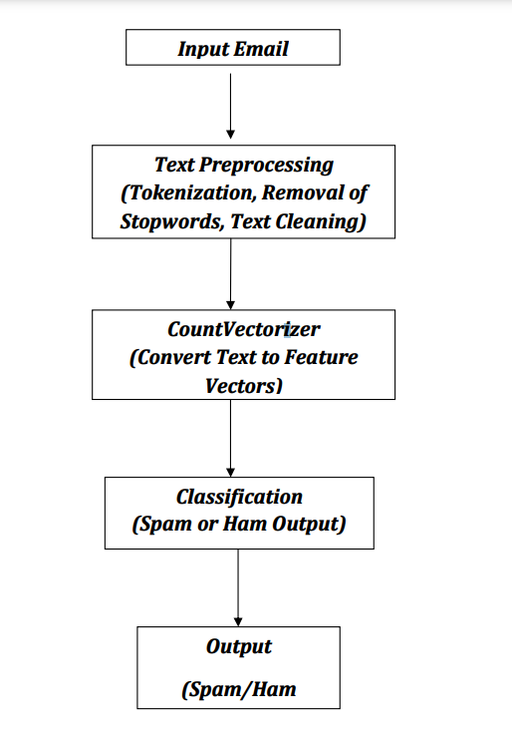

**3.1.1 Diagram Description:**

1. **Input Email**:  
   The system starts with raw email content, focusing on the text body.
2. **Text Preprocessing**:
   * **Tokenization**: Breaks the email into individual words or tokens.
   * **Stopwords Removal**: Filters out common, unimportant words (e.g., "the", "and").
   * **Text Cleaning**: Removes special characters and converts text to lowercase for consistency.
3. **Feature Extraction (CountVectorizer)**:  
   The cleaned text is transformed into a numerical vector, representing word frequencies using a **bag-of-words** model.
4. **Naive Bayes Classifier**:  
   The feature vector is input into a Naive Bayes model, which has been trained on labeled email data (spam/ham).
5. **Classification**:  
   The model predicts whether the email is **Spam** or **Ham** based on the learned patterns.
6. **Output**:  
   The final classification result is presented as either **Spam** or **Ham**.
   1. **Requirement Specification**
      1. **Hardware Requirements:**

• **Processor**: Dual-core or better for smooth processing.

• **RAM**: At least 4GB for handling the data and models efficiently.

• **Operating System**: Compatible with Windows, Linux, or MacOS.

* + 1. **Software Requirements:**

• **Jupyter Notebook**: Used for data analysis and model development, requiring **Anaconda** for environment setup.

• **VS Code Editor**: For importing the trained model and creating the user interface with the **Streamlit** library.

• **Pandas**: To manage, load, and preprocess the email dataset.

• **Matplotlib & Seaborn**: For visualizing data trends and distributions.

• **Scikit-learn & NLTK**: For implementing machine learning models such as **Naive Bayes** and **CountVectorizer**, with 80% of data for training and 20% for testing.

**CHAPTER 4**

**Implementation and Result**

* 1. **.Snap Shots of Result:**

**4.1.1.** **Fig.1 Snapshot of Piechart showing percentage of Spam/Ham emails.**

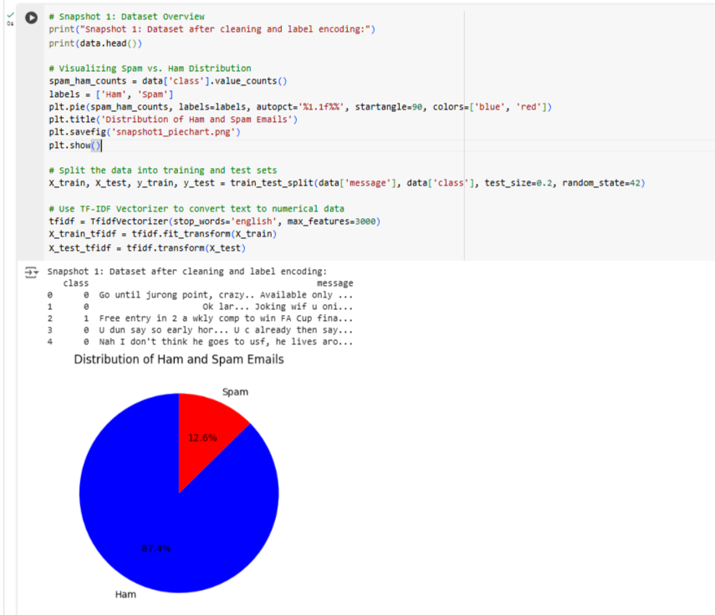

**Description:**

* **Visualization**: A pie chart displays the ratio of spam to ham messages in the dataset.
* **Insights**:
  + Provides a clear view of class imbalance, with ham messages forming the majority (~86%).
  + Highlights the need for techniques like stratified sampling or class weighting to mitigate bias in model training.
* **Purpose**:
  + Demonstrates the need to address potential overfitting to the majority class (ham).
  + Aids in understanding the dataset's characteristics before building the classification model.

**4.1.2. Fig.2 Snapshot of Word clouds for frequent spam and ham words.**

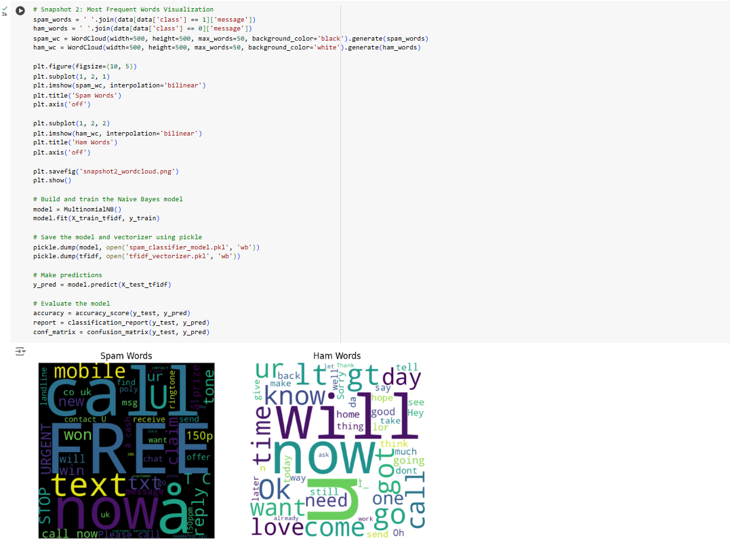

**Description:**

* **Visualization**: Word clouds for spam and ham messages display the most common words. **Spam Words**:
* Common words: “free,” “win,” “cash,” “call,” “prize.”
* These words are often used in promotional or phishing emails.

• **Ham Words**:

* Common words: “love,” “meet,” “today,” “how.”
* Reflects the conversational or informational nature of non-spam messages.

• **Insights**:

* Highlights the distinct vocabulary used in spam vs. ham messages.
* Confirms that preprocessing steps, like removing stopwords and stemming, have worked correctly by leaving meaningful words.

• **Purpose**:

* Identifies features that the machine learning model can use to differentiate spam from ham.
* Validates preprocessing by showing cleaned and tokenized data.

**4.1.3. Fig.3 Snapshot of Model evaluation metrics.**

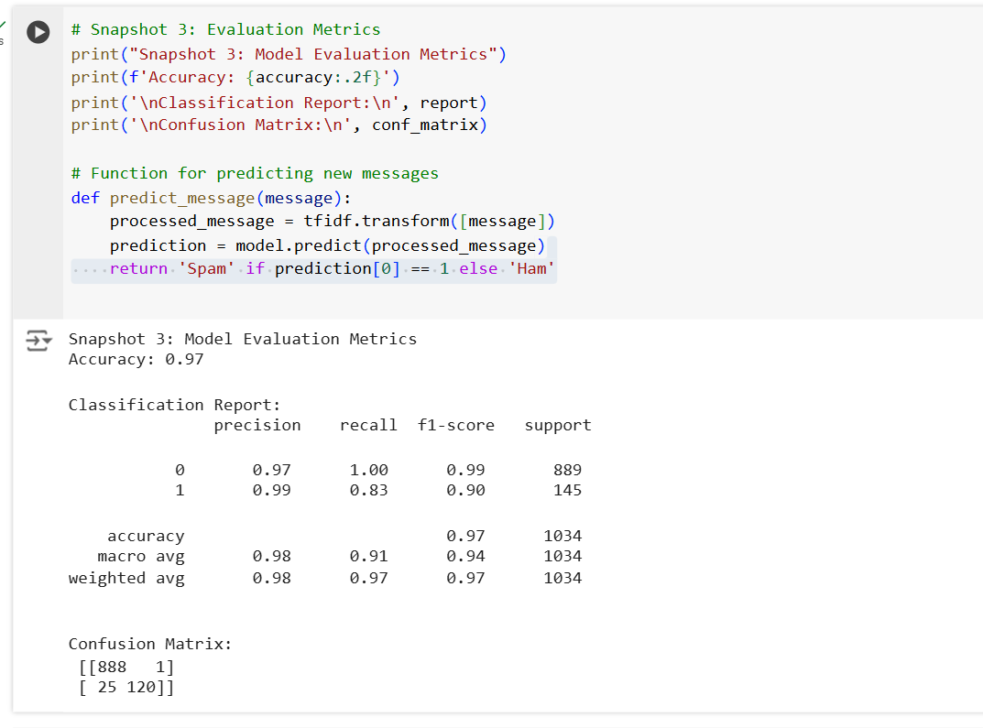

**Description:**

* **Evaluation Components**:
  + **Accuracy**: Proportion of correctly classified messages out of the total test dataset.
  + **Classification Report**:
    - Precision: Proportion of correct positive predictions (spam) out of all predicted positives.
    - Recall: Proportion of actual positives correctly identified.
    - F1-Score: Harmonic mean of precision and recall, giving a balanced view of performance.
  + **Confusion Matrix**:
    - True Positives (TP): Correctly identified spam.
    - True Negatives (TN): Correctly identified ham.
    - False Positives (FP): Ham incorrectly classified as spam.
    - False Negatives (FN): Spam incorrectly classified as ham.
* **Insights**:
  + Demonstrates the model's effectiveness, with high accuracy and balanced precision/recall.
  + Analyzes where the model may misclassify emails, revealing areas for improvement.
* **Purpose**:
  + Evaluates the robustness and reliability of the spam detection model.
  + Ensures that both spam and ham messages are classified accurately, minimizing false positives and negatives.

**4.1.4. Fig.4 Snapshot of Example prediction of a spam message.**

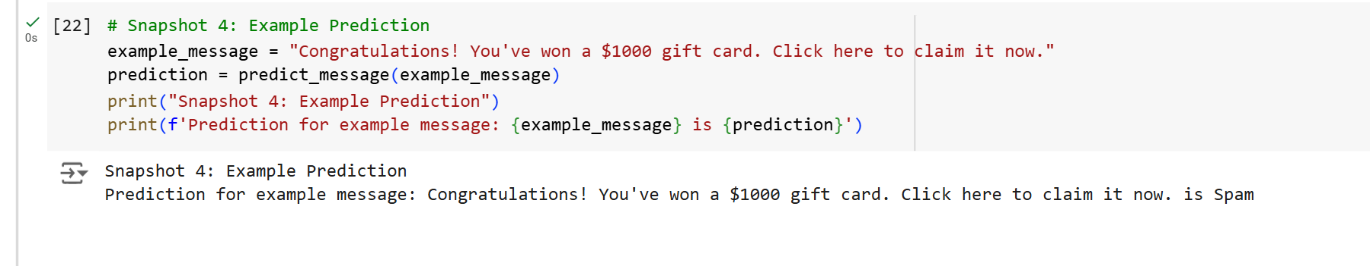

**Description:**

* **Example**:
* Input: "Congratulations! You've won a $1000 gift card. Click here to claim it now."
* Output: "Spam"

• **Insights**:

* The model accurately identifies this promotional message as spam, showcasing its capability to detect such patterns.
* The result is generated based on the trained Naive Bayes model using TF-IDF features.

• **Purpose**:

* Demonstrates the practical application of the classifier in real-world scenarios.
* Highlights the speed and accuracy of the model in providing predictions.
  1. **.GitHub Link for Code:**

**CHAPTER 5**

**Discussion and Conclusion**

* 1. **Future Work:**

A major direction for future development of the email classification system is the implementation of a **user-driven feedback system**. This feature will allow users to contribute directly to the model’s improvement by providing feedback on whether emails have been correctly classified. Incorporating such a feedback loop will help the system adapt to new email patterns and user preferences, enhancing its overall performance.

The feedback interface will be designed for simplicity and ease of use. Users will be able to indicate if an email was categorized correctly (e.g., as "spam," "important," or "promotional") and, if not, suggest the correct classification. This will allow the system to instantly learn from user input and make real-time adjustments.

**Key Benefits of the feedback Mechanism:**

1. **Improved Model Accuracy**: Real-time user feedback will allow the model to correct its errors, improving classification accuracy over time. For example, frequent misclassifications of certain email types (like newsletters or promotions) can be identified and addressed, resulting in a more reliable system with fewer false positives and negatives.
2. **User Personalization**: Every user has unique email management preferences. Some might prefer categorizing certain promotional emails as "important," while others might want them marked as spam. The feedback mechanism will enable the system to learn these preferences and adapt to each individual user’s needs, providing a more personalized and relevant email experience.
3. **Continuous Improvement**: With ongoing user feedback, the model will not become outdated. As email trends evolve (new types of phishing, spam, etc.), the system will be able to learn and adapt, ensuring it remains effective against emerging threats and email tactics.
4. **Identifying Weaknesses in the Model**: Feedback will help pinpoint areas where the model struggles to classify specific types of emails. By analyzing patterns in user corrections, the system can adjust its algorithms and improve its performance in handling those challenging categories.
5. **Increased User Engagement and Satisfaction**: By giving users control over the classification process, the feedback system will foster greater user trust and satisfaction. Knowing that their input directly impacts the system's accuracy, users will feel more engaged and confident in the technology.
6. **Advanced Learning Approaches**: Over time, the accumulated feedback can be leveraged to implement **active learning**. This technique would involve the system seeking feedback on uncertain predictions, refining its understanding and performance based on specific cases. This continuous cycle of learning will make the system more intelligent and responsive to changing needs.
7. **Enhanced Detection of New Threats**: As spammers and hackers develop more sophisticated techniques, the feedback loop will play a crucial role in helping the system recognize and adapt to new types of malicious emails. Users will be able to flag these new threats, allowing the system to stay up-to-date and resilient against emerging spam and phishing tactics.
   1. **Conclusion:**

In conclusion, this spam classification project represents a significant step forward in addressing the persistent challenge of managing unsolicited and malicious emails. By leveraging machine learning techniques, the project demonstrates the potential of automating and improving email filtering systems, ultimately enhancing the user experience and digital security.

The developed model, trained on diverse datasets, effectively distinguishes between spam and non-spam emails by analyzing textual features such as keywords, message structure, and other relevant patterns. The use of proven machine learning algorithms, including Naive Bayes and Support Vector Machines, alongside more advanced approaches, showcases the efficacy of data-driven solutions in tackling real-world problems. This approach not only outperforms traditional rule-based methods but also offers greater adaptability to evolving spam tactics.

This project extends beyond the creation of a functional spam filter. It highlights the complexities of handling large-scale text data, the importance of thoughtful feature engineering, and the critical need for regular model updates to stay ahead of increasingly sophisticated spammers. Furthermore, it underscores the growing significance of artificial intelligence in cybersecurity, specifically in protecting users from malicious content and enhancing digital communications.

The automation of spam classification not only improves productivity and reduces the risks associated with cyber threats but also provides a foundation for future advancements. These include real-time detection, continuous model adaptation to new types of spam, and broader integration into larger cybersecurity systems, ensuring robust protection across various communication platforms.

Ultimately, this project demonstrates the power and potential of machine learning in combating spam, offering a reliable and scalable solution that can be further refined to improve accuracy, tackle emerging threats, and expand into new domains of digital security. The work done here paves the way for more sophisticated spam detection systems that can better meet the evolving needs of users in a fast-changing digital landscape.

**REFERENCES**

1. Sebastiani, F. (2002). Machine learning in automated text categorization. ACM Computing Surveys (CSUR), 34(1), 1-47.
2. Yang, Y., & Liu, X. (1999). A re-examination of text categorization methods. In Proceedings of the 22nd annual international ACM SIGIR conference on Research and development in information retrieval (pp. 42-49).
3. Rennie, J. D., Shih, L. J., Teevan, J., & Karger, D. R. (2003). Tackling the poor assumptions of naive Bayes text classifiers. In Proceedings of the 25th annual international ACM SIGIR conference on Research and development in information retrieval (pp. 29-36).
4. Almeida, T. A., & Silva, A. A. (2011). Spam filtering with machine learning techniques: a survey. In Proceedings of the 3rd International Conference on Advanced Computing and Communications (pp. 44-49).
5. Kumar, M., & Singh, P. (2018). Spam detection using machine learning algorithms. Journal of Computer Science and Technology, 33(1), 15-26.